**Journal of Applied Computer Science & Artificial Intelligence**

**Research Paper Vol.-2, Issue- 1, June 2022 ISSN: 2582-8673**

S-CART | WELCOME BUDDY

**SHUBHANJAN BARAI1*, RIYA DUTTA2, SANA ASGAR3, SAUNAK NANDI4, SONALI BHATTACHARYYA5, DR. PRANATI RAKSHIT6**

1,2,3,4,5,6 Department of Computer Science & Engineering, Kalyani, Nadia, West Bengal, India

**Available online at: http://jacsai.org**

Received: ………. /2022, Revised: ………..2022, Accepted: ………2022, Published:.. /June/2022

*Abstract*— The purpose of the project is to provide a student-friendly Website. Students have mobiles on which they play games, watch movies also do shopping. It's hectic work to find products that are of good quality and long-lasting. S-Cart provides multiple options to choose from like bags, mugs, pencil boxes, bottles, reading materials, toys for learning, etc. Students can log into the Website and can fulfill their wishes by ordering great products at a low price. After a lot of research, we found many problems in some of the E-commerce websites that are very complex to use, but S-Cart has a great User Interface or rather a Colorful Interface to engage more people. Even Parents can Order for their Kids, some gifts or other regularly used products. Even parents can use the “Emergency Delivery” mode to get the products delivered early but for this early delivery additional charges are applied on the whole amount, but this will ultimately result in the happiness of their Kids. As the website will grow more features will be added further. In Simple words, the purpose of S-Cart is to add happiness to the life of an individual.

Keywords—E-commerce, User-friendly, Growth, Security, Web Application, Business, Profit, Student

# **Introduction**

Any Form of Business transactions that are managed online is referred to as e-commerce. Online shopping is one of the best examples of e-commerce. Online shopping can be anything like buying goods or selling goods through the internet. We can do online shopping from any device. Apart from online shopping, we can perform various other tasks such as internet banking, ticketing, payments, and online auctions. E-commerce, also known as electronic commerce, is the exchange of services or goods over the internet. It is your crowded city center or brick-and-mortar shop which is interpreted into zeroes and ones on the information superhighway. Around 2.14 billion individuals worldwide tend to buy services and goods online. E-commerce is a way for numerous people to buy and sell products online. E-commerce allows small businesses and large companies or start-ups to sell their goods and connect with people around the globe. Several companies use e-commerce to sell their products online, but for numerous companies, it is a distribution channel that is included in broader strategies like physical stores and revenue systems. S-Cart is an online

shopping website, which means an e-Commerce website where people of all ages can buy stationery products such as scissors, project paper, pencil boxes, etc. within a very affordable price range. It takes care of all security aspects and assists the user in securing orders and payments. Both logged-in and guest users can use and shop on the website securely. Users can make a secure payment through PayPal, debit card, credit card, or cash on delivery.

**The purpose of the contribution statement** is nowadays retail stores are facing huge competition in the market. Good store designs are seeking more customer attention toward their stores and are increasing the store goodwill and cost also plays a major role in seeking customers' attention and selection of their store. Industry research has shown that there is much need to know about the customer's expectations, preferences, choices, and the features expect from the store or shop. And we will find out the possible solutions for creating and developing the best store which will get more customers and produce more profits.

# **iii. Related Work**

In paper [1] Amandeep, Ashwini Verma, Satyam Chaudhary, and Vikram Thakur have talked about the challenges faced by eCommerce websites like connecting with rural areas, difficulty in earning customers trust new websites, and fraud sellers. They have also described some of the best tech stacks to create a simple dynamic responsive website. The technologies used for creating the e-commerce websites are HTML & CSS for designing the responsive front page, Node JS that handle the back-end stuffs like login/registration, and NoSQL database like here MongoDB has been used to store user data.

In paper [2], Vipin Jain, Bindoo Malviya, and Satyendra Arya have discussed the facilities and benefits provided by an eCommerce website. Our service is available 24*4. It is created in a user-friendly manner so that whoever visits the site can understand its functionality of the website. Since all the necessary products are available in one place it will save a lot of time for the customer. We are also helping in building trust between the supplier and customer and hence promoting small brands and stores.

In paper [3], Theresa A. Kraft and Ratika Kakar have discussed the security needed for an eCommerce website. Using password encryption to protect users' information. We assure 100% safe transactions and customers can make easy online payments without the fear of getting scammed.

In paper [4], Jie Lu, Dianshuang Wu, Mingsong Mao, Wei Wang, and Guangquan Zhang have discussed the recommendation system in an eCommerce website. So the recommendation system uses a machine-learning algorithm behind the scene and suggests and predicts and displays those products to the customers that they mostly look for and the products with discounts or those which are mostly searched, by different customers.

In paper [5], Siriporn Thananuraksakul has discussed the factor influencing online business which reveals that people who have previous experience of purchasing goods online tend to buy more online goods. An eCommerce website should have the ability to gain customers' trust to increase its sale and a website on which students can rely upon. A simple and user-friendly website attracts many new customers. Discounts and low price attract more people as every customer first compare websites based on the price of a product.

In paper [6], S Fatonah, A Yulandari, and F W Wibowo have talked about e-payment or online payment on e-commerce websites. Since everything is going online and everyone has a credit card with them so it's easy to do online payments as it is easy and just takes some seconds to make payment. Our website also has online payment features which are done through Phone Pe and is a fully secured way of payment and assured safe transactions.

# **Methodology**

For the methodology part, the website system is parted into three vital roles, 1) Front-end for the user interface, 2) Backend for storing and organizing data, and 3) Database Management System.

**Front-end**: - Front-end technologies are related to the User Interface and are more visible. Changes in your front-end will directly change the user experience in powerful and meaningful ways. First, when the user enters the website using the link, the user gets a web page called the home page which is always located in the root directory of any website. The home page includes a navigation bar that provides links to different sections within the website and a search bar that allows users to search for what they are looking for.

**Back-end**: -The back end processes the data from the front end to the database and when required it also processes the data from the database to the front end. Basically, NodeJS is a highly scalable and powerful language for the back end.

**Database**: - Database is used to store the important data for the user when he/she will store the items in the cart, whenever they log in checking their credentials, displaying the cart items, displaying the products in the UI section, etc. MongoDB Cloud works fine and is highly scalable in terms of storing data securely.

To represent the workflow of the E-commerce website, the flow diagram of S-Cart is as follows in figure 1.

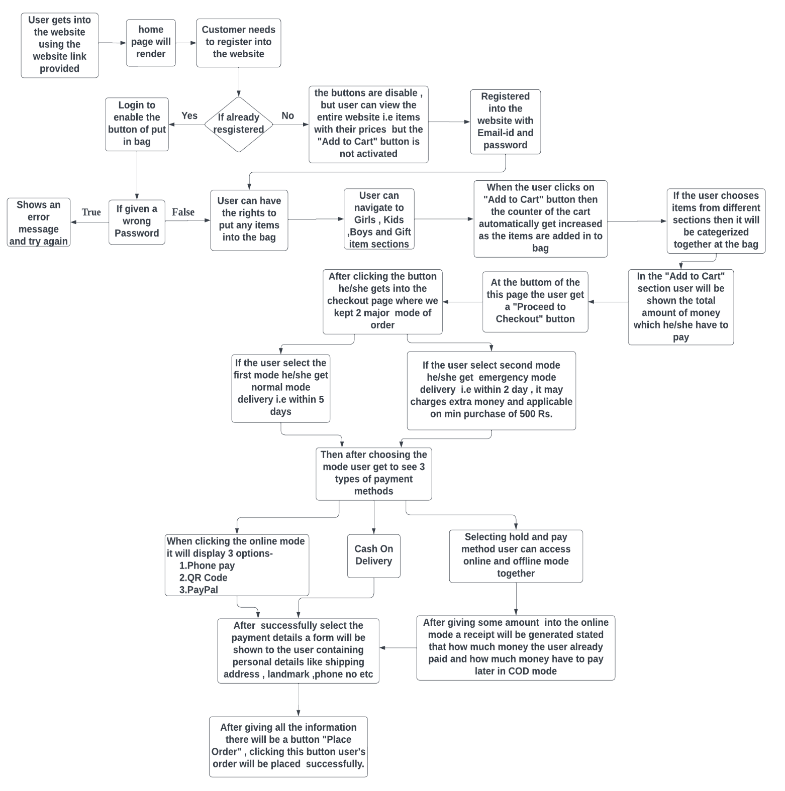**Flow Diagram:** -

Figure 1: Flow Diagram of S-CART

**IV.** **RESULTS AND DISCUSSION**

The ‘S -CART | WELCOME BUDDY’ service aims to provide solutions to develop and transfer in an easy and efficient way in this generation of digital India and to help save human time and make things comfortable with the help of technology. It is a website specially designed for students, where they can purchase a variety of stationery items from

the comfort of their homes, hostels, or wherever they are present. “S-CART | WELCOME BUDDY” is an e-commerce website that is very student-friendly and helps students to overcome the shortage of stationery products such as scissors, and project papers, designed in a user-friendly manner. It features a familiar and well-thought-out, attractive user interface, combined with strong searching functionality.

Home Page Preview: -

Figure 2: Home Page Interface

On the login and registration page, existing customers can log in to buy products and new users have to create an account for buying the product. The customer is assured that their personal information and data will not be shared and hence secured. The figure for the user login and registration page is given below in Figure 3 & Figure 4 respectively.

Login Page Preview: -

Figure 3: Login Page Interface

Registration Page Preview: -

Figure 4: Registration Page Interface

On the home page, we also have different sections for everyone that are Boys’, Girls’, Kids’, and Gifts items where people can go and buy according to their wish. The section preview of Boys is shown in Figure 5.

Boys’ Section Preview: -

Figure 5: Boys’ Section

Similarly, the Girls’, Kids’, and Gifts sections are also there.

In the Add to Cart Section when the user Adds some items, then it reflects in the cart section, and it will also show the amount of money the user has to pay. Figure 6 will show the whole process.

Figure 6: Cart Page Interference

At the final check-out section, the user must give the shipment details to proceed further. By providing the details the user can enter the payment section. Figure 7 is for the Final Checkout and Add Shipping Information method is given below:

Figure 7: Checkout Page for user

This website consists of two modes of orders which are Normal Mode and Emergency Mode.

Figure 8: Payment Section

In normal mode, the product is delivered on the usual date which is within two to four days. The emergency mode is used when the product is required by the student urgently and the product is delivered in a very short period of time. As emergency mode gives extremely fast delivery additional charges will be applied depending upon the distance and time given for delivery. Figures 9 and 10 represent the normal and emergency mode.

Figure 9: Modal to understand Normal Delivery

Figure 10: Modal to understand Emergency Delivery

Another most important features are the three modes of payment methods which are Online payment, Cash on delivery, and Hold and Pay payment. As a result, this website proves to be the best friend in the lives of college or school students making their work easier and swallowing a lot of their time. “Hold and Pay” is the integration of both Online and Cash on delivery modes. Customers can pay a part of the amount online and the leftover part can be paid at the time of the delivery.

# **Conclusion and Future Scope**

This project is created to satisfy the needs of a student and help them whenever there is a need for some stationery products. This website shall prove to be a simple and reliable website in satisfying all the requirements of the students. The main motive of this website is to provide students with all types of stationery products necessary for their studies or projects. This website provides various products that will benefit the customers visiting this website. It makes the entire process online where users can search for the products they need in their daily life or for some particular work. It also has an admin’s login where admins can add, update, or delete various items, and review customers’ activity. Whenever the admin notices some products that are not getting sold due to high prices, the new discounted price will be avail to the customers so as to clear the inventory. In general, we took care of all the factors that influence customers’ demand for shopping i.e., quality of products, services, cost of products, and discounts to continuously be better, faster, and affordable. In this generation, businesses need to consider the new needs, choices, and demands of the customers because it is important for the growth, sale, and survival of their business in the long term. The growth and development of the Internet and e-commerce, create more opportunities for profit and advancements for businesses while creating more product choices for customers.

E-commerce is expanding day by day, people are looking for applications that met their needs for shopping. Mostly there are mobile users, in the future, S-Cart will be available in Mobile Version also. Android Development of the Website will be the future but for the time being, it will be a Web application. Many users are confused whenever they visit any website, about how to get started and shop, it would be better if there is an assistant that will help them in directing or guiding about the different components of the website. It’s basically a contact assistant where auto-generated messages will be coded, and answers will be set accordingly.

# **Vi. Acknowledgment**

First of all, we would like to thank our supervisor of the project, Mrs. Sonali Bhattacharyya, for her wonderful support, assistance, and guidance while creating this project. Without her, it would not be possible to complete this project. We would also like to show our gratitude to Mrs. Pranati Rakshit for making it possible for us to perform our project and for all her support. And finally, we would like to thank all the members of our who helped to create the Project.

# **vii. References**

1. Amandeep, Ashwini Verma, Satyam Chaudhary, Vikram Thakur “A Review & Development of E-Commerce Website”, International Research Journal of Engineering and Technology (IRJET), Volume: 09 Issue: 04 | Apr 2022
2. Vipin Jain, Bindoo Malvia, Satyandra Arya “An Overview of Electronic Commerce (e-Commerce) ”, Journal of Contemporary Issues in Business and Government Vol. 27, No. 3, 2021
3. Theresa A. Kraft and Ratika Kakar “E-Commerce Security”, School of Computer Science, University of Michigan – Flint, MI 48502, USA Sat, Nov 7, 11:30 - 11:55, Crystal
4. Jie Lu, Dianshuang Wu, Mingsong Mao, Wei Wang, Guangquan Zhang “Recommender system application developments: a survey.Decision Support Systems, International Journals Sciences. 74(6), pp.12-32”
5. Siriporn Thananuraksakul “Factors influencing online shopping behavior intention: A study of Thai consumers”, AU Journal of Management, 5(1), pp. 41-46, Vol. 5 No. 1 (2007), 14-02-2018
6. S Fatonah, A Yulandari and F W Wibowo “A Review of E-Payment System in E-Commerce”, Dept. of Informatics Engineering MTI Amikom University Yogyakarta, Indonesia 2018
7. K.M. Rahman1, "A Narrative Literature Review and E-Commerce Website Research", EAI.EU, vol. 5, 2018
8. Nazmun Nessa Moon, Shaheena Sultana, Fernaz Narin Nur & Mohd Saifuzzaman, "A Literature Review of the Trend of Electronic Commerce in Bangladesh Perspective", Global Journal of Management and Business Research: B Economics and Commerce, vol.17, Issue 3 Version 1.0, 2017
9. Stanley Frederick W.T. Lim, Xin Jin, and Jagjit Singh Srai, "Consumer-driven e-commerce", International Journal of Physical Distribution & Logistics Management Vol. 48 No. 3, pp. 308-332, 2018
10. Madhurima Khosla1, Harish Kumar2, "Growth of E-commerce in India: An Analytical Review of Literature", IOSR Journal of Business and Management (IOSR-JBM), vol.19, issue 6, PP 91-95, 2017
11. Alexandru Ioan Cuza, " UNDERSTANDING E-COMMERCE ADOPTION. LITERATURE REVIEW OF COMPETING MODELS ", SEA - Practical Application of Science Volume V, Issue 13 (1 / 2017)
12. Mark Anthony Camilleri, "E-commerce websites, consumer order fulfillment, and after-sales service satisfaction: The customer is always right, even after the shopping cart check-out", University of Malta, Malta and University of Edinburgh, Scotland. (2021).

**Authors Profile**

Author SHUBHANJAN BARAI is pursuing a Bachelor of Technology (B.Tech) in Computer Science and Engineering from JIS College Of Engineering, Kalyani, Nadia.

Author RIYA DUTTA is pursuing a Bachelor of technology

(B.Tech) in Computer Science and Engineering from JIS College Of Engineering, Kalyani, Nadia.

Author SANA ASGAR is pursuing a Bachelor of technology

(B.Tech) in Computer Science and Engineering from JIS College Of Engineering, Kalyani, Nadia.

Author SAUNAK NANDI is pursuing a Bachelor of Technology (B.Tech) in Computer Science and Engineering from JIS College Of Engineering, Kalyani, Nadia.

Author SONALI BHATTACHARYYA is an Assistant Professor of the Dept of CSE at JISCE, a renowned engineering college. Her research domains are Soft Computing, Machine Learning, Bioinformatics, etc.

Author Dr. PRANATI RAKSHIT presently working as an Assistant Professor at JIS College of Engineering, Kalyani, Nadia, West Bengal, India. She has completed her Ph.D. degree from Jadavpur University, Kolkata, West Bengal, in the field of Pattern Recognition, Machine Learning, and Medical image analysis She has worked in the field of Pattern Recognition, Machine Learning, Medical image analysis, Data Mining, Image Processing, IoT, etc. She has 45 numbers of research publications in international journals and conferences including SCI and Scopus indexing.